UAP CSE Faculty Shines Globally
2025-01-01 — 2026-02-16

Department Updates
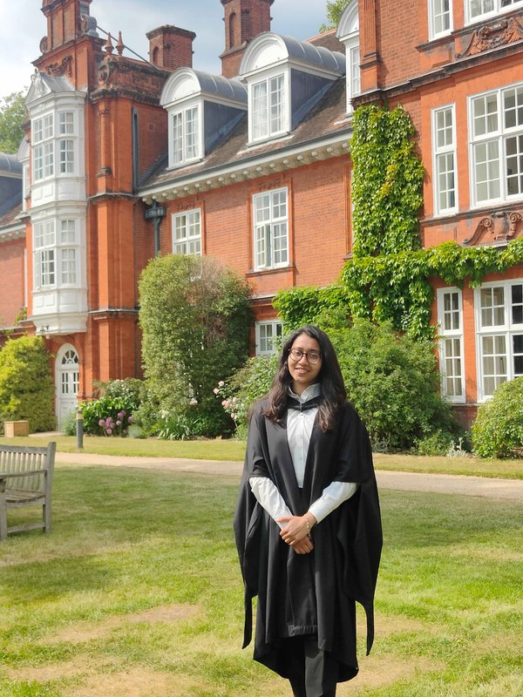

From Classroom to Cambridge and Back: Faria Zarin Subah’s Inspiring Journey at UAP
Others
January 15, 2026
· By: Durjoy Mistry
Faria Zarin Subah completed her BSc in CSE atChittagong University of Engineering and Technologyand joined theUniversity of Asia Pacificin 2022 as a Lecturer. She taught core and advanced courses while supervising machine learning–based student projects. In 2023, she pursued an MPhil in Machine Learning at theUniversity of Cambridgeunder the Prime Minister’s Fellowship, researching fairness-aware AI. She returned in 2025 and was promoted to Assistant Professor.
Read full post →
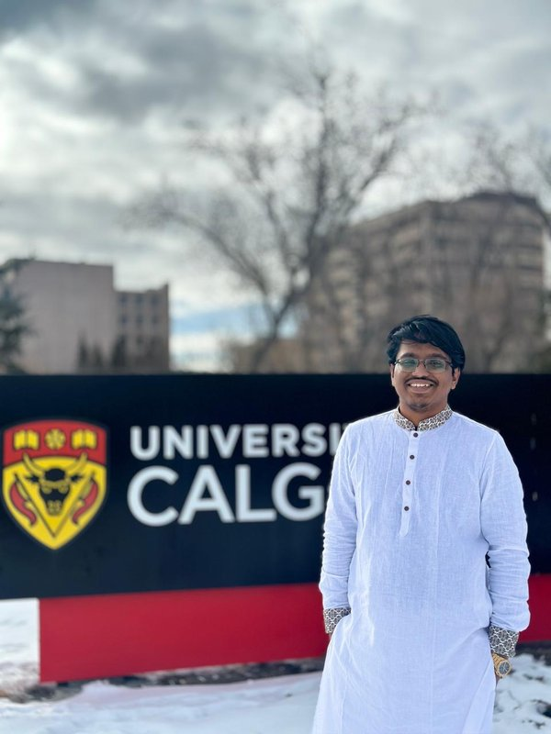

From UAP Undergraduate to Global Scholar and Back: Celebrating Rashik Rahman’s Inspiring Academic Journey
Others
January 13, 2026
· By: Durjoy Mistry
Rashik Rahman began his academic journey in CSE at theUniversity of Asia Pacific, publishing research even before graduating in 2021. He joined UAP as a Lecturer in 2022, helping strengthen its research culture and establish a research lab. In 2023, he pursued an MSc in Computer Science at theUniversity of Calgary, graduating with a 3.92 CGPA. Rejoining UAP in 2025, he continues to inspire students and advance research.
Read full post →
Department of Computer Science & Engineering
University of Asia Pacific
Generated on February 16, 2026 at 01:14 AM

